CV

Modern
*
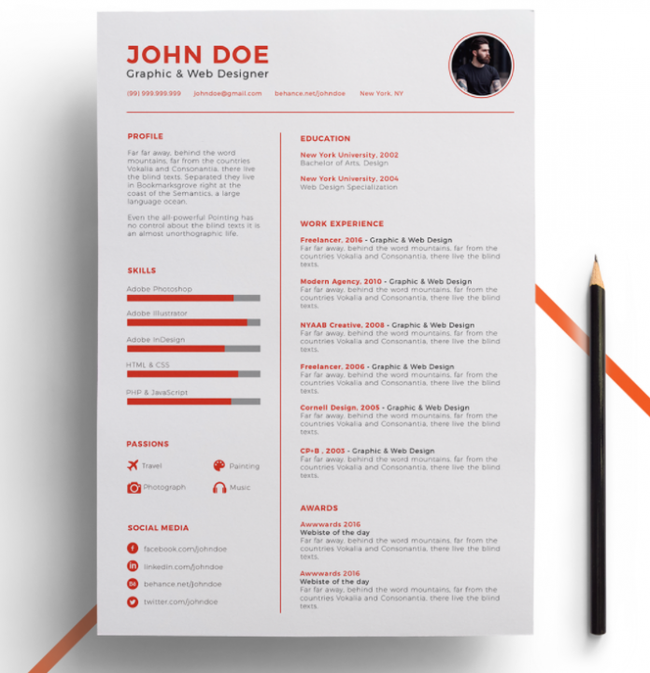 https://utemplates.net/free-resume-cv-templates
*
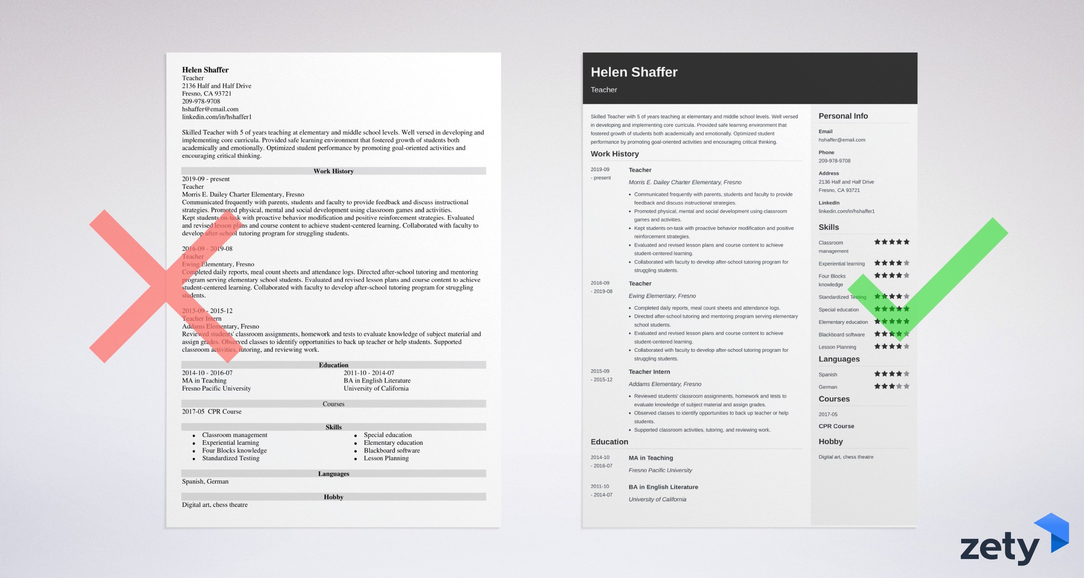 https://zety.com/cv-examples/
*
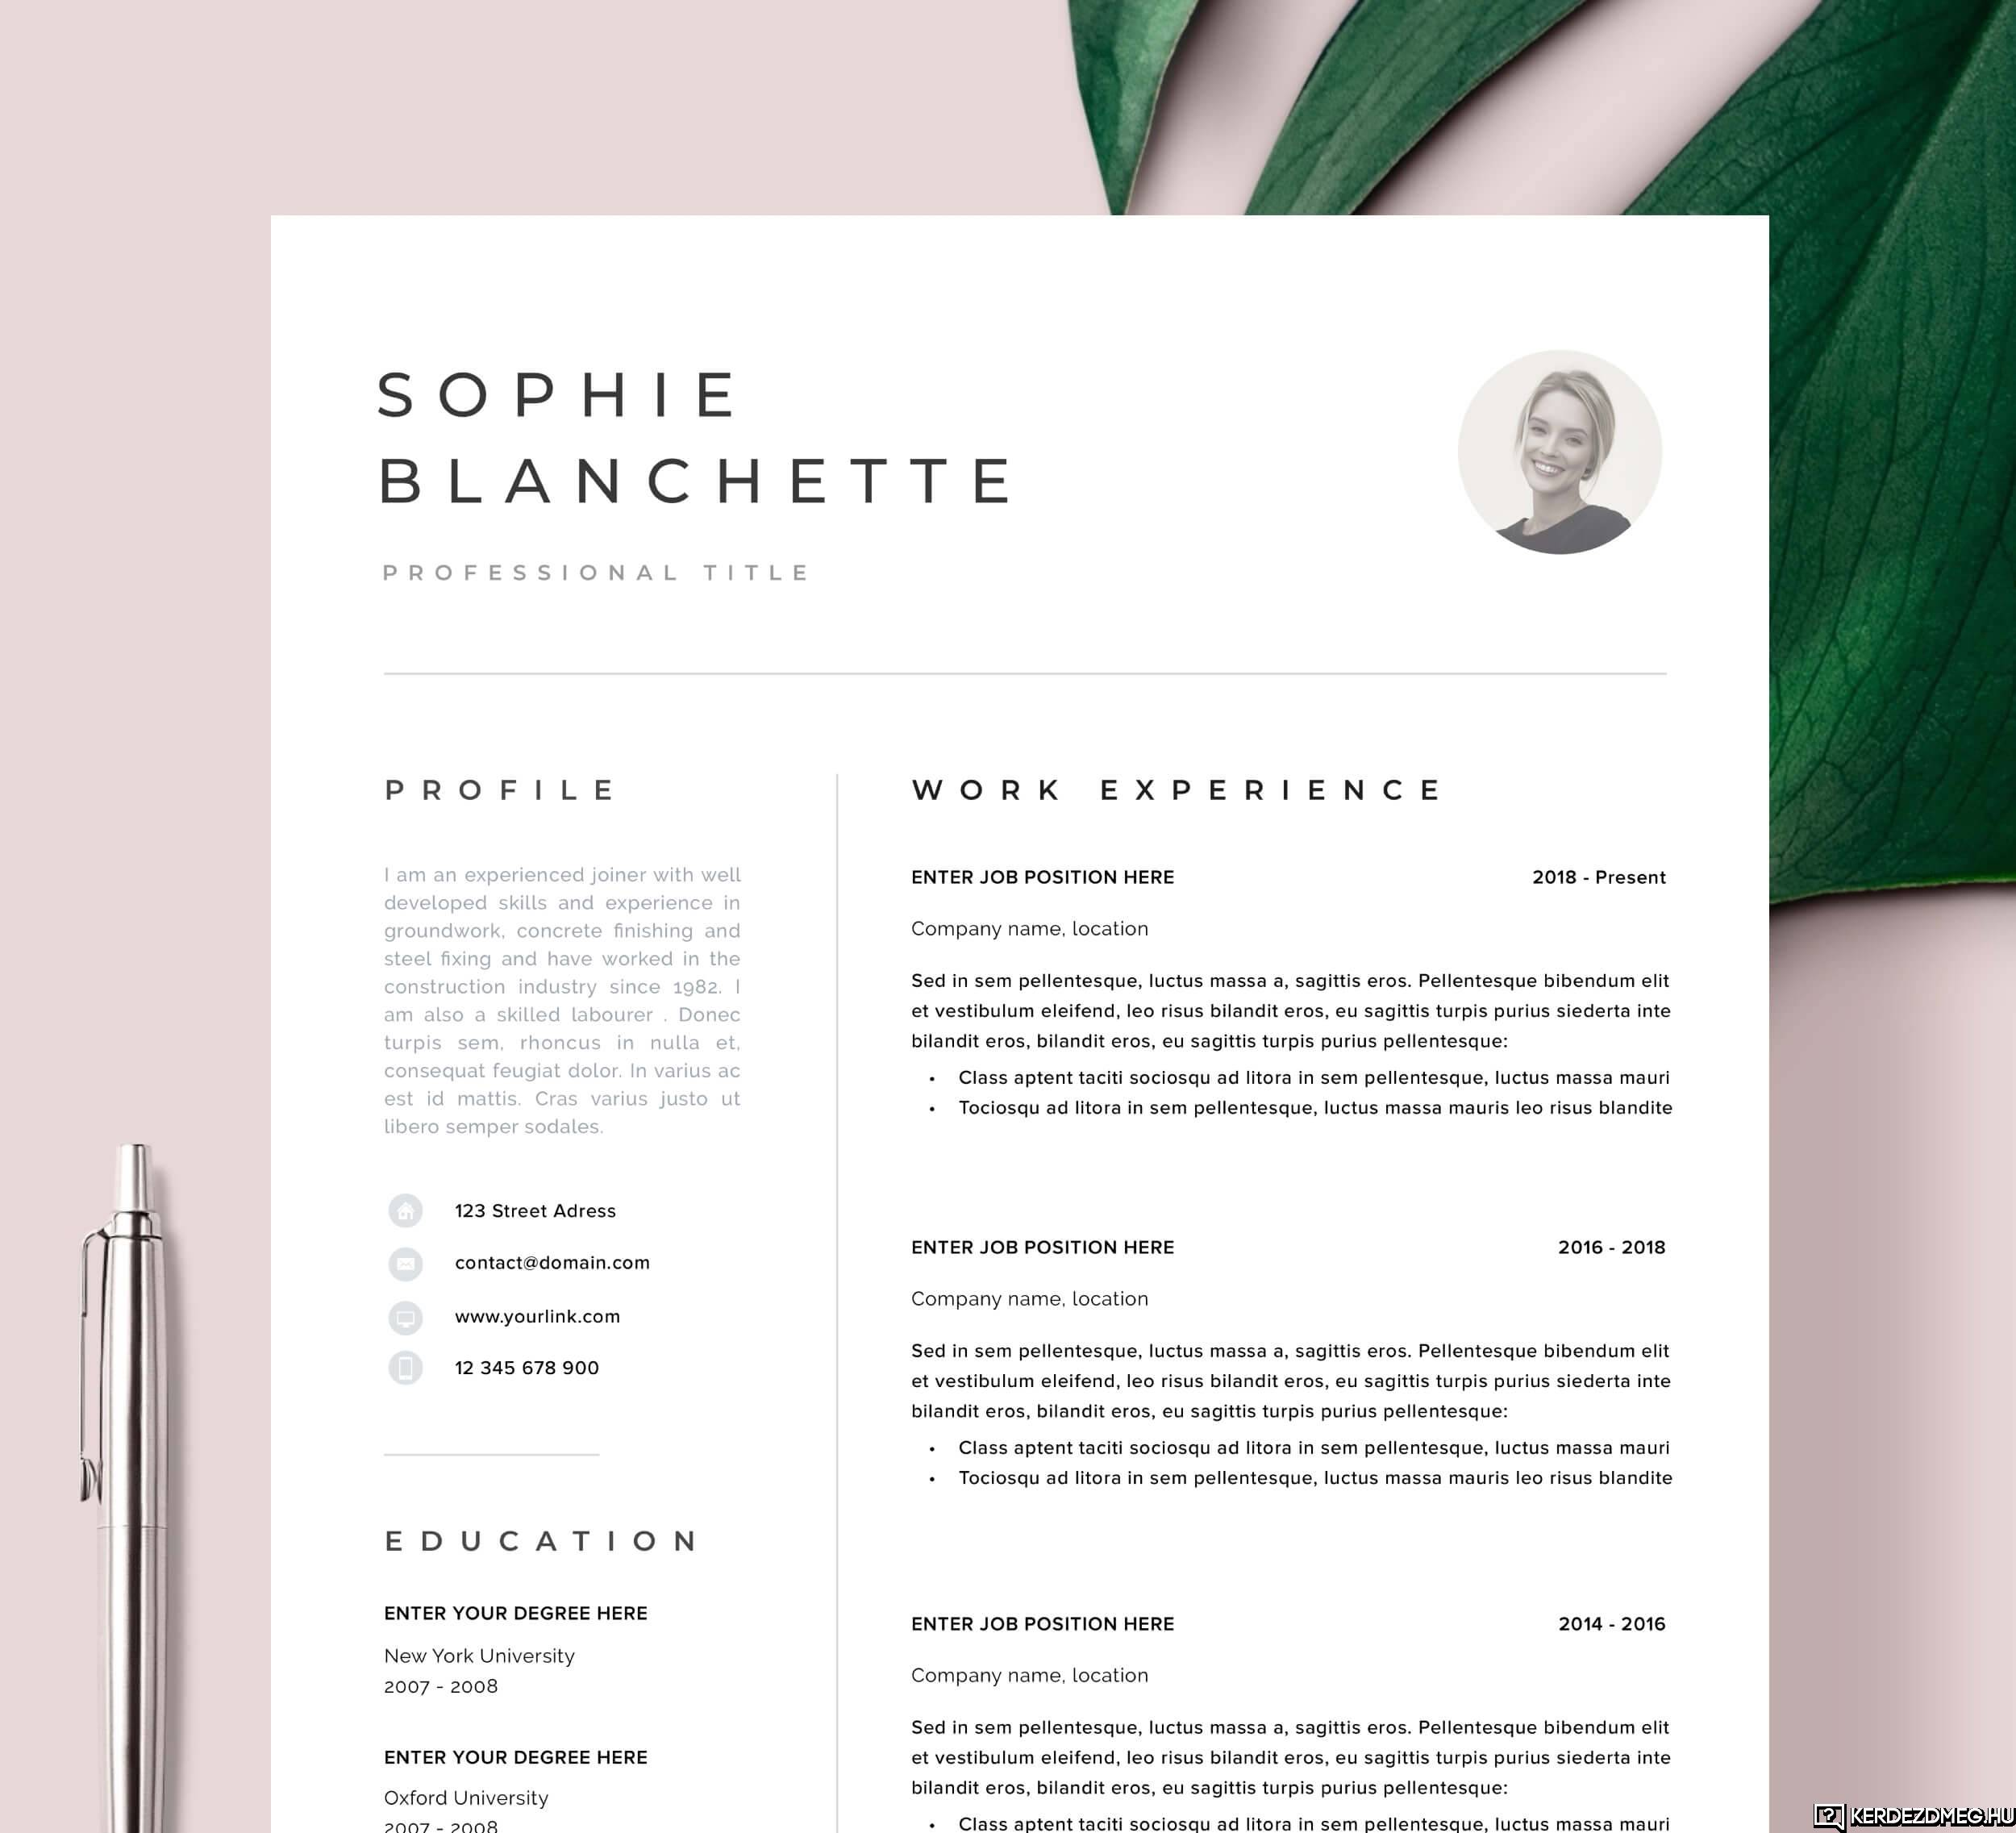 https://kerdezdmeg.hu/kerdes/cv-curriculum-vitae-mit-jelent-ez-a-kifejezes
*
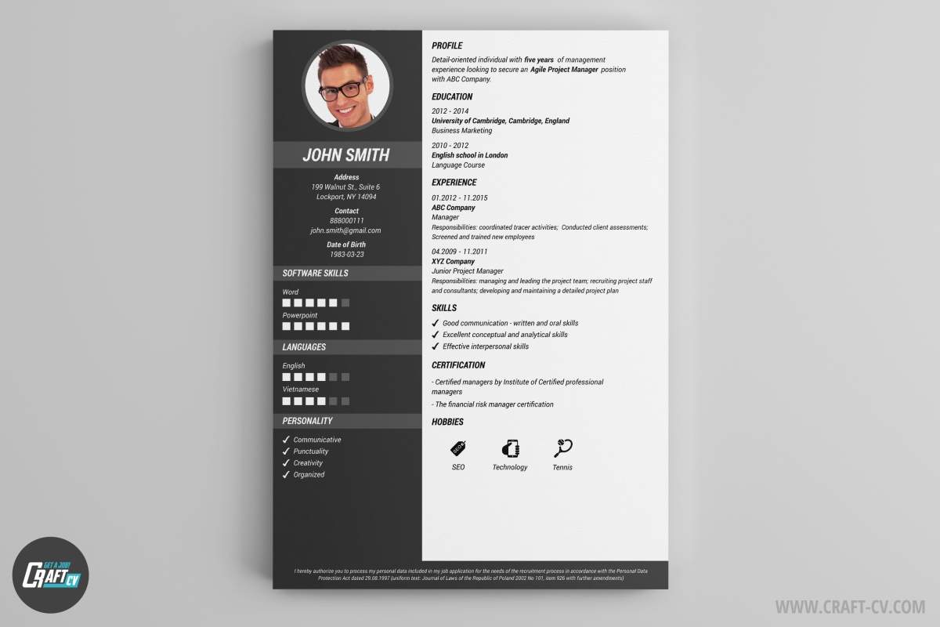 https://craft-cv.com/en-us/resume-templates
*
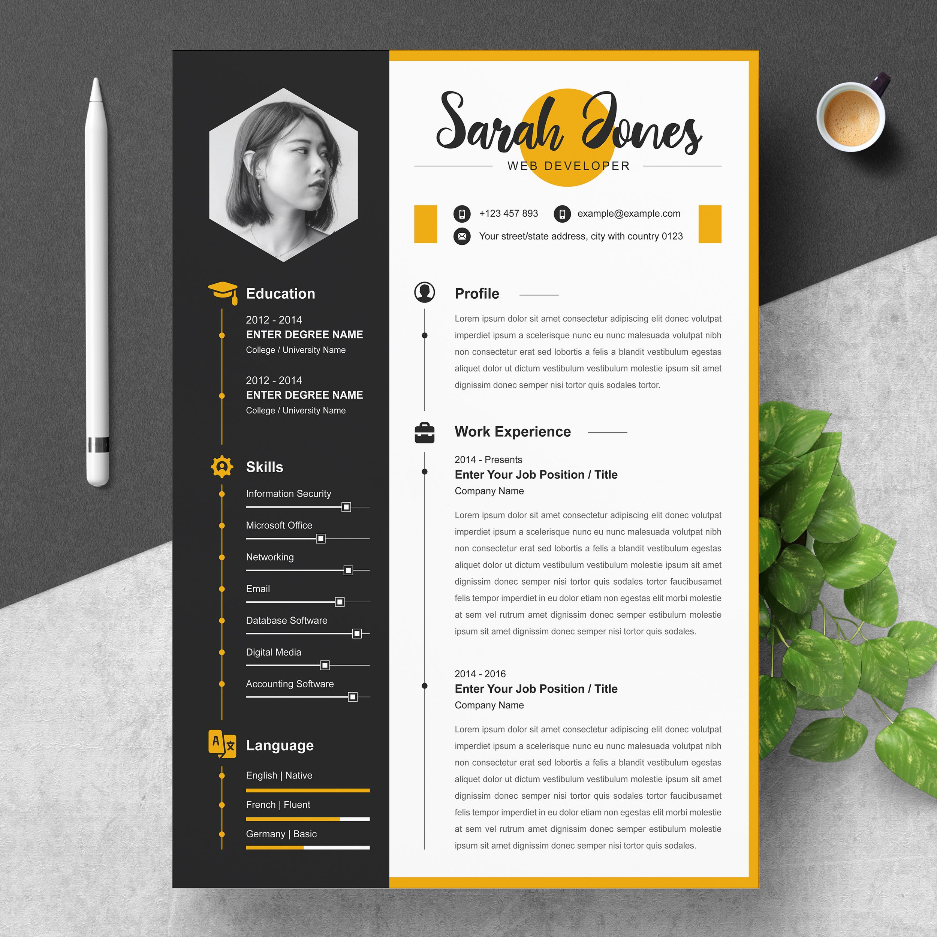 https://creativemarket.com/Resume-Inventor/5407067-Professional-Creative-Resume-CV
*
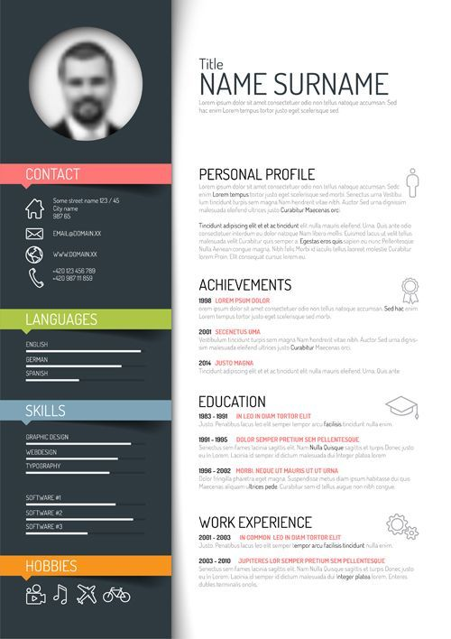 https://www.pinterest.it/pin/556194622722121842

